Test Plan Documentation

Prepared for: WireApps Ltd

Prepared by: Asheni Sandeepa

Document: QA Technical Assessment

**01) Analyzing the testing product (Introduction)**The product which is planned to be tested is the google translator which is an open-source application which is offered by google to translate different languages. There are probably around 100 languages due to which it has become one of the most popular cross language communication tools.

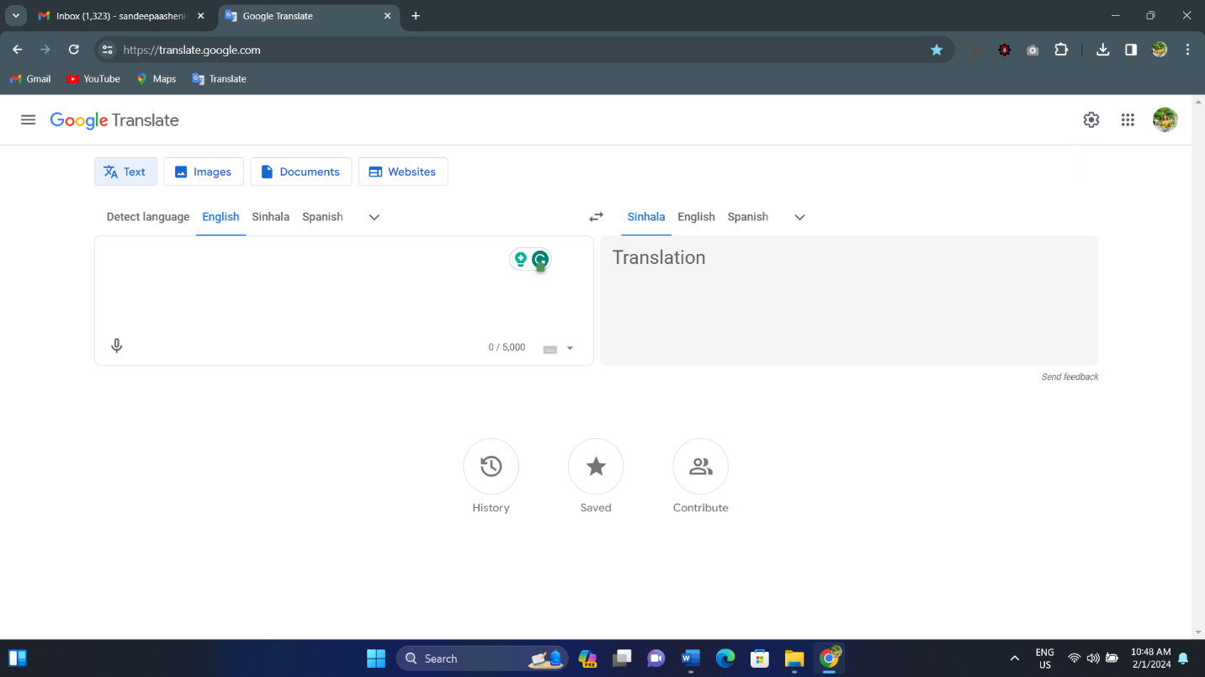

Interface Of The Application

**02)The Purpose of the testing conducted**

The main reason for this test is to ensure that the functionality of the application is up to date, the usability (user experience) and the performance of the google translator application in different languages and to find out if there are any failings in these commonly used applications.

**03)The Scope**

The application will be tested under different circumstances to have a deep quality check were,

* The performance of the product over different browsers
* Responsive testing
* User Interface and
* Compatibility

**04) Objectives of the testing conducted**

* Compile a set of sample texts in English, Tamil, and Sinhala that address a range of subjects, including formal writing, technical content, and general discussion.
* Google Translate should be used to translate each sample text. Make a note of any differences or mistranslations.
* Examine the user interface's readability and usability by watching participants as they carry out routine actions including text entry, language selection, and translation review.
* Monitor server resources such as CPU usage, memory consumption, and network bandwidth during peak loads to identify potential bottlenecks or performance issues.
* Evaluate the overall responsiveness and stability of the translation service under varying loads.
* Test the application on different web browsers including Chrome, Firefox, Safari, and Edge.

**05)Testing Environments**

Because this is an online platform the testing environments will be, Web Browsers like Chrome, Firefox, Safari, Edge Languages that should be majorly focused are Sinhala, Tamil, English Can Use different types of OS like Mac OS / windows OS .